**MSC Forecast Location Polygon Package**

**Errata File for MSC Geography V6.0.0beta**

**Outstanding Issues**

1. The forth coverage depiction, hybrid needs to be added to the water sets.
2. The latest addition to the version 5.8.0 of the MSC polygon package is the CAP-CP geo-coded shapefile. The province of Quebec had already reviewed the data in the Quebec region and discovered some issues related to metadata and/or the shapefile. Presently, a complete list of issues is not available. This may require a collaborative effort and once the appropriate groups review the issues and address them, the corresponding data in the Geography package will be updated and be available in the next few major/minor versions of the package.
3. The coverage maps needed to be updated to reflect the changes in coverage shapefiles in version 6.0.0beta.
4. Two AQ Sites Estevan and Milton should be in the AQStdSiteP set.

**Resolved Issues**

* As planned, shapefiles of the forecast zones have been regenerated using a recent base map from NR Can. The previous base zones had been generated using the Digital Chart of the World 1984. A new base map known as Canvec (vector files), a product of NRCan has been used to regenerate the new zones.
* A fourth business usage has been introduced to the Geography package. In addition to coarse, detail and exaggerated, the hybrid set, which is combination of detail (for inland) and exaggerated (for shoreline) was added as the fourth business usage. In this version, only the land hybrid has been added.

**Business Rules for Version 6 Hybrid Set**

The general rule for the hybrid set is to use detailed boundary for areas inland and exaggerated boundary for areas over water. However, there are several exceptions identified below with an example:

* The only waterbodies that will appear in the hybrid set are Lake Manitoba, Lake Winnipegosis and Lake Winnipeg. For these waterbodies, detailed boundary would be used, whereas the exaggerated boundary would apply to the adjacent land polygons.

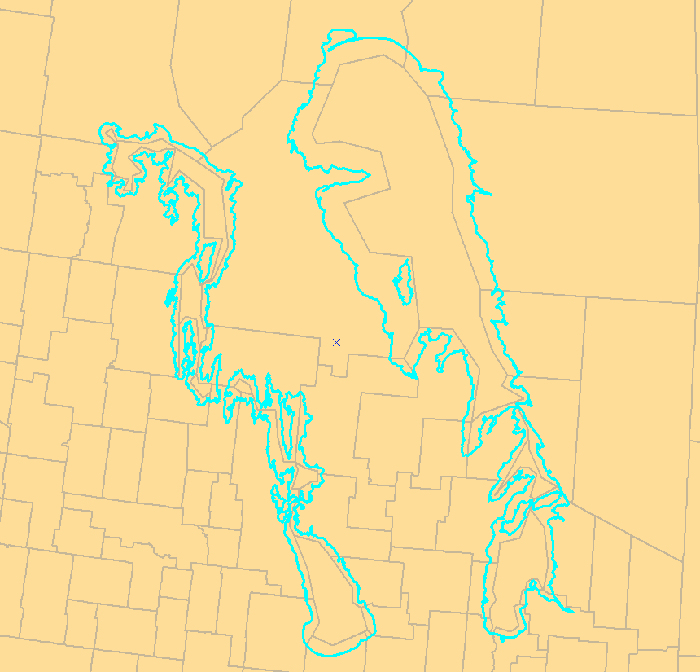

• Use detailed boundary for provincial border.

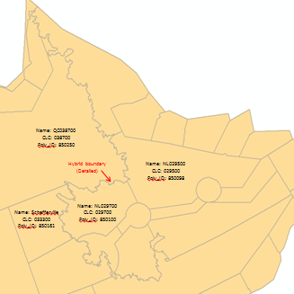

* Use exaggerated boundary for unattributed zones, if it is not a provincial border.

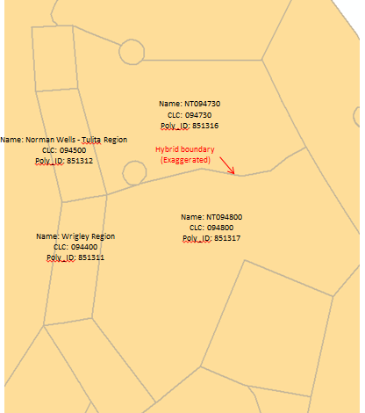

* For polygons adjacent to a river or lake, a generalized boundary would be created to enclose all the associated polygons that belong to a zone, without creating overlaps with other land polygons. In the figure below, zones are color-coded by the corresponding CLC.

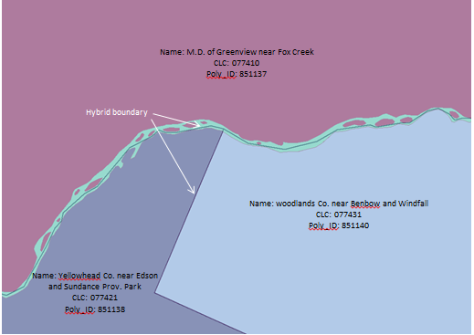

* Suggestion has been made to add other larger waterbodies (inland water) to the existing water polygon sets. This will be done using one of the CanVec products (NR Canada – hydro shape file). There were number rivers and lakes have been added to the water detal sets
* An attempt was made to reduce the number vertices of each polygon in the exaggerated set.

**Business Rules for Version 6 Exaggerated Set**

The intent of the exaggerated set is to reduce the number of vertices of each polygon. Compared to detailed and coarse sets, polygons in the exaggerated set are represented by generalized boundaries. No waterbodies (i.e. rivers and lakes) are shown in the exaggerated set, except for Lake Manitoba, Lake Winnipeg and Lake Winnipegosis.

However, an overlapping boundary is created, when:

* Near the shorelines, where there are multiple islands dispersedly-located.

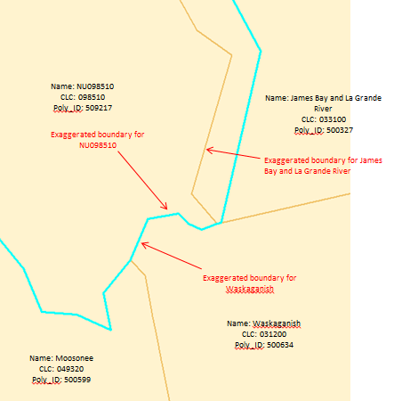

* Between two complicated land polygons, excluding provincial boundary.

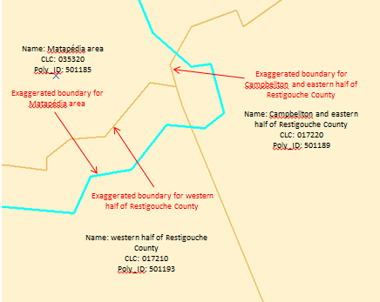

* Between two land polygons adjacent to a narrow or complicated river.

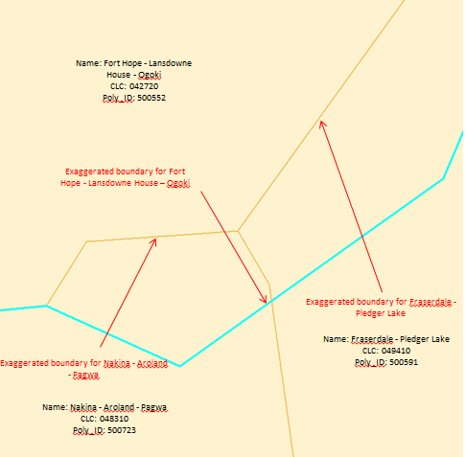

1. In the land_CLCBaseZone_coarse data set, part of the polygon that represents Kangiqsualujjuaq (CLC_V5 039800) is missing as shown in the original image. (red circled area). Also some unattributed areas around Kangiqsualujjuaq are missing. (black circled areas). They need to be added to the layer in the next version.

Original Image

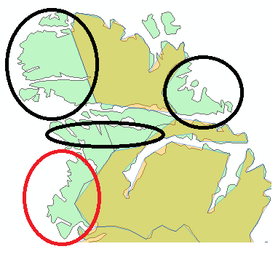

Corrected Image

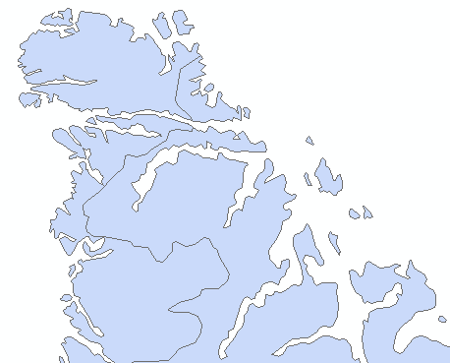

1. In the CLCBaseSiteP_detail set, the POlY_ID range is incorrect. It should start with 830….
2. All coverage shapefiles have been regenerated only for detail coverage depiction. The table below lists the coverage shapefiles from version 5.8.0 and version 6.0.0beta

|  |  |
| --- | --- |
| Coveage Name in version5.8.0 | Coveage Name in version 6.0.0beta |
| AQHIWOCovZone | AQHICov |
| AQIWLCovZone | AQICov |
| PubWWCovZone  PubWUFCovZone  PubWOCovZone | PubCov |
| MarWHCovZone  MarWQCovZone | MarCov |
| TsuWECovZone | TsuCov |

1. Several water base layers contains an incorrect polygon boundary near the polygon that represents the forecast zone known as Grand Manan (CLC_V5 003220) as shown in original image. It should be corrected as shown in the corrected image. All affected layers are listed in the table below.

|  |
| --- |
| Layer name |
| Water_CLCBaseZone_coarse |
| Water_CLCBaseZone_detail |
| Water_MarStdZone_coarse |
| Water_MarStdZone_detail |
| Water_MarSubZone_coarse |
| Water_MarSubZone_detail |

Original Image

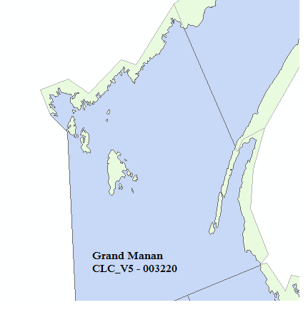

Corrected Image

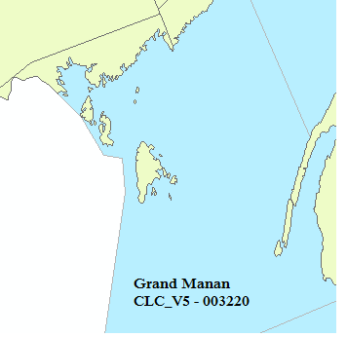

1. Northern Quebec was not part of PubMesoCovZone as shown in the original Image. In version 6.0.0 it has been added as shown in the corrected image.

Original Image

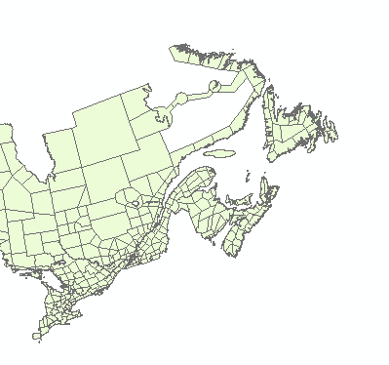

Corrected Image

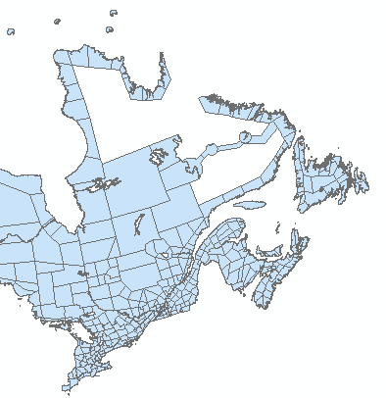

1. The following derived sets no longer exist in version 6.0.0beta
   1. PubOtherCovSite
   2. PubOtherCovzone
   3. HurTCStdZone
2. Geometry files are generated and available still in txt format in version 6.0.0beta with a different data display. Below are screen captures of geometry file in version 5.8.0 and version 6.0.0beta

version 5.8.0 format

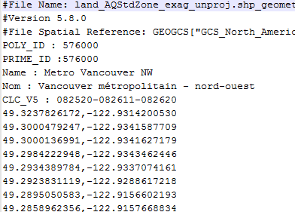

version 6.0.0beta format

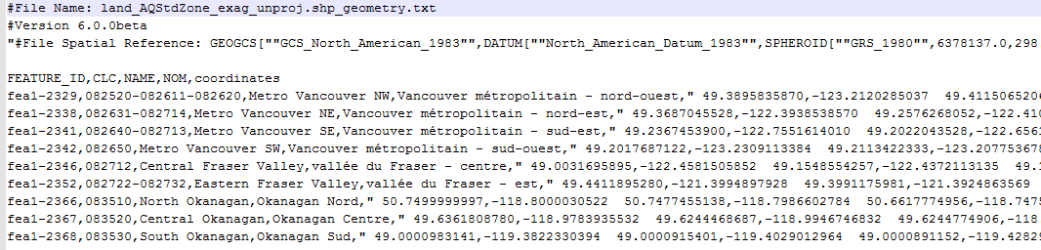

1. A new BC road segment (Yellowhead Highway – Tête Jaune Cache to the Alberta Border/ Route Yellowhead – de Tête Jaune Cache à la frontière de l’Alberta will be added to BaseSite, CLCBaseSite and PubStdSiteL. In addition to that, an existing one in BaseSite (Goldstream to Cowichan Bay) will be added to PubStdTDSiteLwith an updated name : Malahat  Highway – Goldstream to Mill Bay/ Route Malahat – de Goldstream à Mill Bay
2. All derived sets are categorized into two groups, internal and external as described in the Readme document.
3. In water exaggerated set, remove all land polygons by extending the boundary of the water polygons around it.
4. In version 6.0.0beta a new attribute field has been introduced. This is referred to as “FEATURE_ID”. This attribute field represents a unique id that is used in identifying a single feature across all business usages. Also the CLC_V5 attribute field has been renamed as CLC in version 6.0.0beta.
5. The IceMaStdZone has been updated to add more zones to have more up to date derived set. This was done based on the input received from the ice Services.
6. In version 5.8.0, the polygon that represents Forrester Island has been included with Hadai Gwaii as shown in the original image. It has been removed as shown in the corrected image.

Original Image

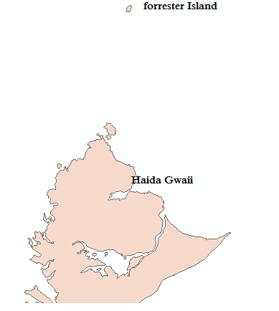

Corrected Image

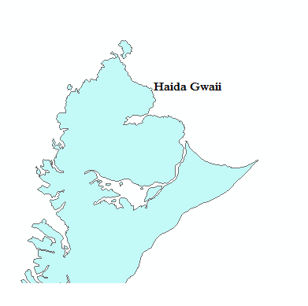

1. The AQHICov derived set (previously known as AQHIWOCovZone) has been updated by removing and adding the following zones/sites

* Remove Prince George (zone)
* Add East Vancouver Island - Nanoose Bay to Fanny Bay (zone)
* Add the following AQ sites: WestShore, Victoria/Saanich, Duncan, Nanaimo/Parksville, Comox Valley and Campbell River.

1. The following three AQ sites needs to be added to the CLCBaseSite set and AQStdSite set.

|  |  |  |
| --- | --- | --- |
| Polygon Set | location | CLC |
| CLCBaseSite | Estevan  Milton  Airdrie | 060005  040048  070022 |
| AQStdSite | Airdrie | 070022 |

1. North America boundary shape files both projected and unprojected are included in this 6.0.0beta package to help to visualize the maps. They are:
   * north_america_boundary_proj
   * north_america_boundary