**MSC Forecast Location Polygon Package**

**Errata File for MSC Geography V5.7.0**

**Outstanding Issues**

**January 2017**

1. Future plans to recreate the shapefiles of the forecast zones using a more recent base map from NR Can. The current base zones had been generated using the Digital Chart of the World 1984. The works being carried out to explore the new CanVec (vector files), a product of NRCan further as the most suitable base map for this exercise.
2. Plans are underway to introduce the fourth business usage to the Geography package. In addition to coarse, detail and exaggerated, the hybrid set, which is combination of detail (for inland)and exaggerated (for shoreline) will be added as the fourth business usage.
3. Land polygon boundary contains too much land area (004450).
4. Suggestion has been made to add other larger waterbodies (inland water) to the existing water polygon sets. This will be done using one of the CanVec products (NR Canada – hydro shape file).

**Resolved Issues**

1. A couple of kMZ files in the latest version 5.6.0 are not being displayed on Google Earth. They are land_PubStdZone_detail_proj and land_PubStdZone_exag_proj. They need to be recreated again.
2. In the next version of the polygon package, please add a polygon for the new WQ_21_81_CWTO designation in the MarWQCovZone shapefile. The coverage area and name is the same as the WH_19_79_CWTO designation which covers Lake of the Woods Lake Nipigon North Channel Lake Nipissing and Lake Simcoe.
3. Topology analysis has been run on the land sets to clean a number of small gaps between adjacent polygons. Furthermore the analysis was continued to identify and clean any overlapping areas between polygons. This exercise, result in a significantly low number of vertexes in most polygons in the exaggerated set. Same method was applied to the water sets, however, due to time limitation, the topology analysis was applied to only some areas of the water sets and therefore, the remaining polygons of the water sets still need to go through this exercise prior to next release.
4. A prior request was made to change the name of the Marystown site to Burin, this was implemented in RI16 and then accidentally reversed in RI17. After some consultation, it was decided that a better way to proceed would be to request that a new location for Burin be added and that the Marystown location be removed. This will affect the bulletins FLCN26/36 CYQX.

|  |  |
| --- | --- |
| **Name English** | ~~Marystown~~ Burin |
| **Name French** | ~~Marystown~~ Burin |
| **English Public Forecast Associated** | Burin Peninsula |
| **French Public Forecast Associated** | Péninsule de Burin |
| **Location** | ~~47.1549750 -55.1644333~~  47.0828410 -55.1752720 |
| **Display type** | Point (displayed as circle on Scribe map) |
| **Scribe Point** | XWT |
| **CLC code** | ~~020002~~ 020018 |
| **CGNDB code** | ~~AASOD~~ AADCE |

1. A proposal to change the Public program regional boundaries on the BC west coast in place. This has been design to address the growing needs and expected population changes across the area, by fine tuning these regions it is hoped that more accurate forecasts and alerting will be able to be provided by the forecaster for the affected areas due to climatological differences especially over Metro Vancouver and more recently the North Coast Inland, Central Fraser Valley, and the Fraser Canyon.
2. The potential boundary changes related to urban expansion are obviously most likely to occur with the somewhat rapidly expanding Cities that are their own meso region, though it is possible Cities and Towns that are contained within but close to the boundary of a larger surrounding meso region could also gobble land from the neighboring meso region thereby changing the boundary of their own region in AB.
3. The Air Quality site for Grand Bend (CLC_V5 – 040030) exists in the wrong Public Forecast region due to incorrect polygon boundary between the polygons that represent Goderich - Bluewater - Southern Huron County (CLC_V5 046330) and Watford - Pinery Park - Eastern Lambton County (CLC_V5 – 041310) as shown in the original image. The boundary should be adjusted as shown in the corrected image using the satellite image.

Original Image

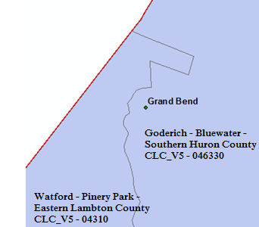

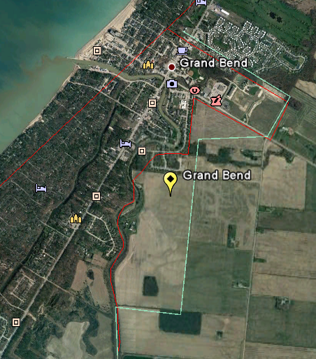

Corrected Image

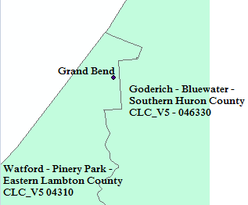

1. In the water base set, the boundary between the the Lake Winnipeg - north basin (CLC_V5 008631) and Playgreen Lake (CLC_V5 not defined yet) does not exists. Boundary between the polygons should be drawn as shown in the corrected image.

Original Image

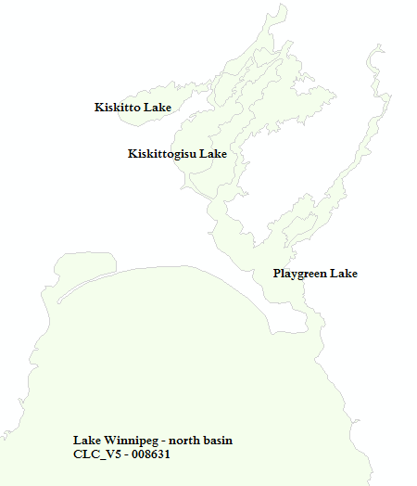

Corrected Image

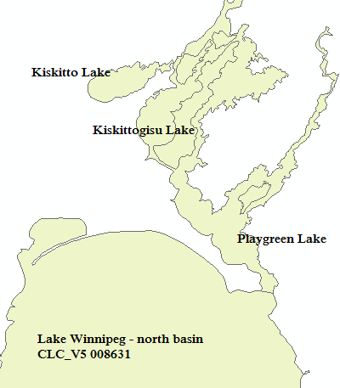

1. In the detail and coarse of land base sets, the north arm of the Lake Winnipeg - north basin (CLC_V5 008631) shown below, contain incorrect values for the following attribute field and they should be corrected as shown in the table below.

Original attribute field values

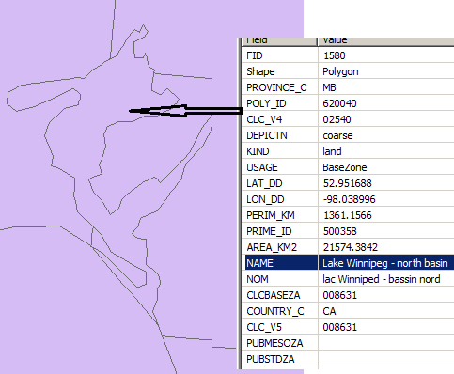

Corrected Image

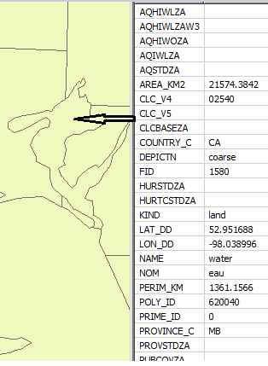

1. In land_PubMesoZone sets, the four Manitoba Lakes are missing as shown in the original image. They need to be added as shown in the corrected image.

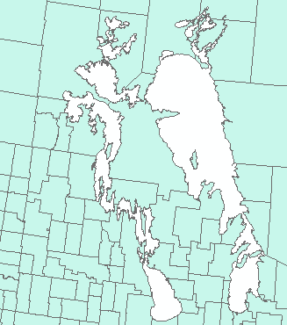Original image

Corrected Image

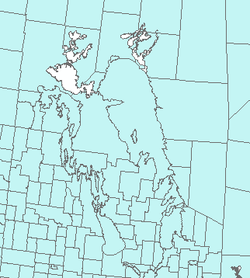

1. In land_PubMesoZone _detail set, some small islands exist near Lake of the Woods that belongs to the United Sates as shown (red circles) on the original image. They should be removed as shown in the corrected image.

Original Image

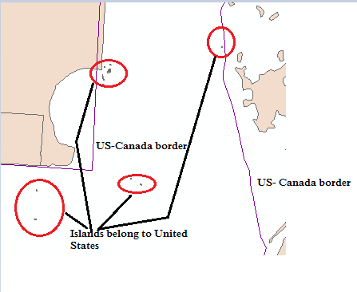

Corrected Image

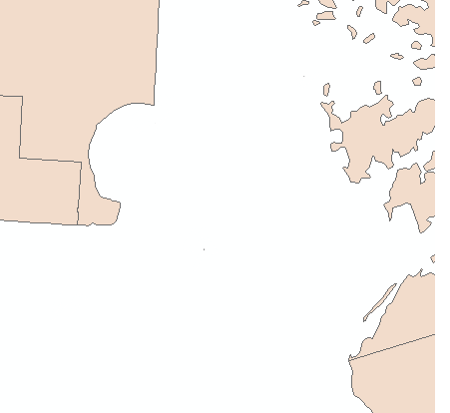

1. Currently in the land_BaseZone_exag, one of the overlapping land polygons near Lake Winnipegosis set (North and South Moose Lake incl. Moose Lake Res., CLC_V5 – 056120) is missing as shown in the original image and that needs to be added to the set as shown in the corrected image.

Original Image

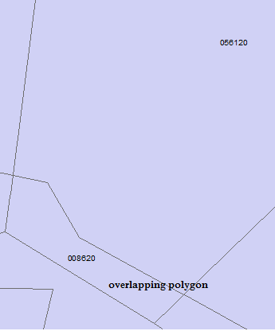

Corrected Image

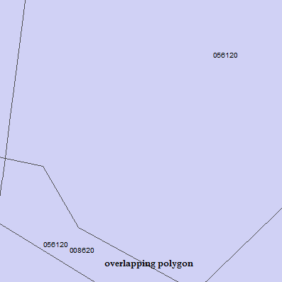

1. In the land_BaseZone_exag set the boundary that dissects the cedar lake is incorrect drawn as shown in the original image. It needs to be corrected as shown in the corrected image.

Original Image

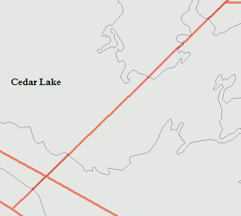

Corrected Image

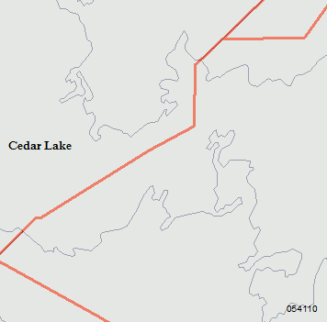

1. The following Tsunami and UGC zones needed CLC_V5 value update due to BC changes.

|  |  |  |
| --- | --- | --- |
| Business Usage | Old CLC_V5 value | New CLC_V5 value |
| Tsunami (TsuStdZone) | 081100-089110-089210 | 081100-089110-089210-089230 |
| UGC (UGCStdZone) | 089210 | 089210-089230 |